Module 6

Assignment 6.2
Course: CSD420-340A Advanced Java for Programmers
Prepared By: Mirach Erkol
Date of Report: 4/26/2026

https://github.com/Mikey5007/csd-420.git

6.2 Assignment: Running in PowerShell
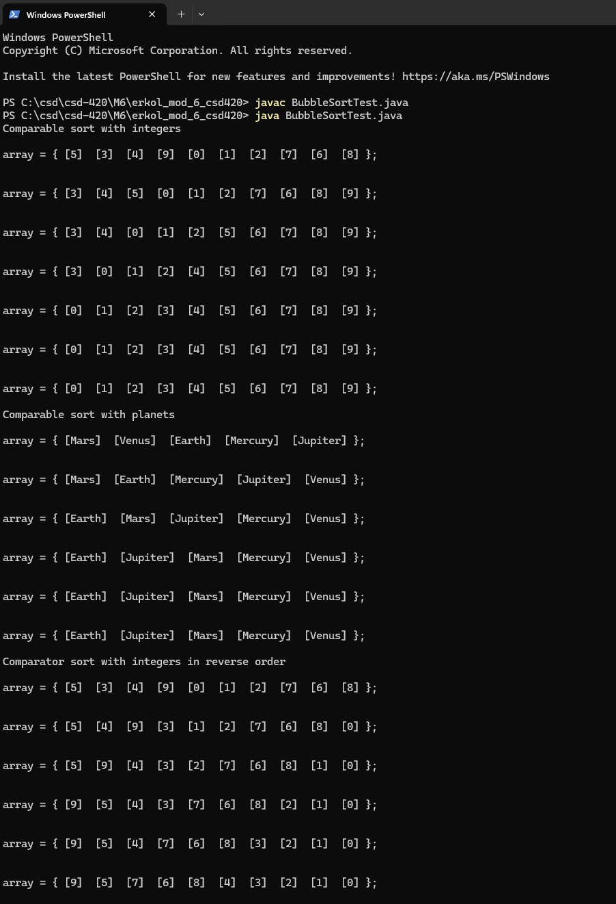
6.2 Assignment: Running in NetBeans
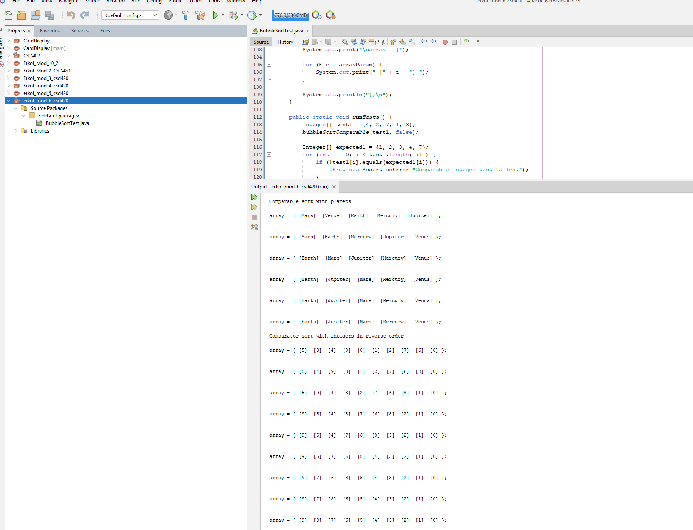

References:

https://github.com/Mikey5007/csd-420.git

